**DISTRIBUTED IOT ENVIRONMENTAL MONITORING**

**by:**

**Mr F.J. Fourie**

**26047799**

**Project Proposal**

submitted in pursuit of the degree

**BACHELOR OF ENGINEERING**

**In**

**COMPUTER AND ELECTRONIC ENGINEERING**

**North-West -University Potchefstroom Campus**

Supervisor: Prof A. Helberg and Dr M Ferreira

Potchefstroom

2018

# Abstract

In this report a literature study was done on the Distributed IOT (Internet of Things) Environmental monitoring system project. This repot specifically looks at the aspects of COP, LoRa, Non-invasive AC Current Sensors, Air Conditioner, Arduino, databases and the anemometer. The above mentioned aspects of the project form part of a solution for monitoring previously installed split type air-conditioning units. The goal of monitoring the split type air-conditioning units, is to determine the efficiency of the unit. Monitoring the efficiency of the split type air-conditioning unit will provide the data required to make decision on whether to repair or replace a unit.

No commercially available solution for distributed IOT environmental monitoring by means of COP (Coefficient of Performance) monitoring of an already installed split type air-conditioning unit. The current universally used commercial solution is to replace a split type air-conditioning unit once it is older than ten years or required several repairs through its lifespan. From the research documented in this report a broader understanding of the elements of this project was created.

Table of Contents

1 Abstract 2

2 Introduction 5

3 Problem Statement 6

4 Project Overview 7

5 Project Scope 8

6 Literature Survey 10

6.1 Previous Solutions 10

6.2 Air Conditioner 10

6.3 COP (Coefficient of Performance) 11

6.4 LoRa 11

6.5 Non-invasive AC Current Sensors 12

6.6 Arduino 13

6.7 Databases 14

6.8 Anemometer 15

7 Conclusion 16

8 References 18

**Table of Figures**

Figure 1: Work Breakdown structure 9

Figure 2: LoRa Network 12

Figure 3: Arduino UNO pin layout 14

Figure 4: An HHF91 Anemometer that can measure CFM 16

**Table of Equations**

Equation 1: Coefficient of performance 11

Equation 2: Maximum COP for an air conditioning system 11

Equation 3: Relationship between current in the secondary and primary winding 13

Equation 4: CT turns Ratio calculation 13

# Introduction

The Distributed IOT Environmental Monitoring project is about the lack of a reliable, more cost effective method with which the COP (Coefficient of Performance) of an already installed split type air-conditioning unit can be monitored. This has the consequence that air conditioning units are kept in operation despite performing less efficient than expected. On the opposite end of the spectrum air conditioning units are replaced before it becomes a liability due to poor performance and therefore replacement becomes necessary. This results in loss of energy and capital for the company. In this project the problem will be attempted to be solved by making use of IOT (Internet of Things) sensors. These IOT sensors will be fitted to existing installed split unit air-conditioners thereby making it a more cost effective solution. These IOT sensors will be able to send data via the internet in order to calculate the COP of any air-conditioning unit at any given time. The data collected from the IOT sensors will be used to enable an estimation of when a unit needs to be repaired or serviced.

Here follows the literature study for the Distributed IOT Environmental Monitoring project. A short overview of the problem will be presented in the problem statement section of the report below. The problem statement explains and substantiate the relevance of the project. A project overview briefly describes what will be done during the project and how it will be done to complete this project to satisfaction. The project scope is also included in the report. This shows what is included and what is excluded from the project. Thereby giving a clear picture of what must be addressed in the project. The importance of this project will be addressed by identifying the unique aspects of the project as well as referring to the shortcomings of already existing solutions and why they are not applicable to this particular problem. This all will be followed by a complete in depth literature survey that will look at all existing documentation and research on the different aspects of the project. Research on different possible solutions of the different aspects presented by the project will be performed. In an attempt to identify the most applicable solution to each one of these aspects that can be used together to complete the project.

# Problem Statement

There is currently a considerable amount of split type air-conditioning units used in large commercial buildings. Most companies that own these buildings handles these split type air-conditioning units in one of two ways. They either replace them after they have reached a predetermined age [1] or they wait for the air-conditioning unit to break. This leads to a loss of capital and the unnecessary wasting of electricity. Electricity is wasted by keeping ineffective split type air-conditioning units in operation. The loss in capital comes from an unnecessary high electricity bill and the wrongful replacement of split type air-conditioning units. This is a problem and a method by which the performance of the air-conditioning unit is used to determine when it needs to be replaced is necessary.

For this the aim of the project is to develop a low cost IOT sensor console that can be installed and used with all currently operational split air-conditioner units in commercial properties. The sensor consoles must be cost efficient in terms that the amount that is saved due to the application of the sensor consoles is more than the cost of the sensor console itself. The sensor console should be capable of calculating the COP of any of the split air-conditioner units at any time. The sensor consoles should record data to send over the internet to a central computer that will interpret and analyse the data in order to gauge the overall condition of a split air-conditioner unit.

The central computer needs to be able to use the received data from the sensors to determine when an air-conditioner unit needs to be repaired or serviced. Predictive maintenance should be made possible by making use of IOT. Predictive maintenance is done by using algorithms to predict when a split type air-conditioner unit is going to break. This should allow the system to automatically call maintenance personnel to the site of the split type air-conditioner unit that is predicted to break. A user friendly GUI (Graphical User Interface) is necessary to make the central computer easy to use and understand for the operator. This enables him to check desired information more easily and effectively. There also needs to be a user friendly method to see which split type air-conditioning units need to be repaired or serviced.

# Project Overview

The first part of the project is the sensor console which will be installed at the split air-conditioner unit. This sensor console will be made up of a small computer such as an Arduino that is connected to a LoRa module and some external sensors. The sensor console will consist of multiple sensors such as temperature sensors to measure intake and output air temperatures. As well as a current sensor to measure the current being drawn by the split air-conditioner unit. The LoRa module will be used to enable the device to communicate and receive and send data to the central computer. The small computer of the sensor console will be used to gather the data from all the sensors connected to it. It will also perform some preliminary basic manipulations of the data received before using the LoRa module to send the data to the central computer.

The second part of the project is the communication between the sensor console and the central computer. As stated above this will be done by using the LoRa standard. As well as making use of a LoRa module on the sensor console to transmit the data and then receive the data at the central computer.

The third part of the project is the central computer that will be used to analyse the data to get valuable real time information about the split air-conditioner units. The data will be processed using algorithms to get valuable information that can then be compared to historical data of that specific split air-conditioner unit as well as the information from other split air-conditioner units. The central computer will need a GUI so that an operator can easily access and see the information as well as recommendations as to how to handle the information. The main statistic that will be used by the central computer to determine when a split air-conditioner unit needs to be repaired or serviced is the COP. COP is independent of many external uncontrollable variables therefore it will be used in this instance. The program will display graphs of the split air-conditioner units COPs over time making it easy to see a decline in the performance of a split air-conditioner unit. The program will have the ability to request data from a sensor console at any point if information on a split air-conditioner unit is needed at that time. Abnormal situations will also be detected such as people leaving their split air-conditioner units on at all times. In such a case an alert will be given to the operator so that there can be followed up on the situation.

# Project Scope

The scope of the project is to design a more cost effective and non-invasive sensor console with a central computer program that the sensor console can communicate with. The sensor console needs to have temperature sensors connected to it that will be used to measure the intake air temperature as well as the output air temperature. A current sensor will be connected to the sensor console and the power supply of the split type air-conditioning unit in order to calculate the input power and to monitor when the split type air-conditioning unit is on. The sensor console is required to be connected to IOT in order to transmit data. To enable the sensor console to transmit data LoRa will be used. LoRa will be used due to the relative inexpensiveness of the necessary LoRa module as well as its relative long range and low power usage. A central computer is necessary that can communicate with all the sensor consoles in that particular building. This central computer will be used to access the sensor consoles and to gather data from them and interpret the data into valuable information. The central computer needs a GUI to enable an operator to access all the information.

The objectives of this project is the design and building of the sensor console and the programming of the back end program that will run on the central computer. This project must make it possible to determine when to service and repair a split type air-conditioning unit based on its COP.

The approach that will be used in solving the problem is:

* Identifying, analysing and understanding the problem
* Exploring and researching possible solutions to the problem
* Identify a solution to the problem then specify and describe the solution
* Design the system that will be used and then create a detailed design of it
* Build the system
* Test the system
* Improve the system and finalize it

For this project the sensor consoles and the back end program is within scope. The gateway and the cloud is not within scope. This means that the transmission between the sensor consoles and the back end program is within scope but that the network it is transmitted over is not within scope. The following Figure 1 shows the work breakdown structure for the Distributed IOT Environmental Monitoring project. The figure shows what is within scope for this project and what is outside scope also shows some of the levels of the project.

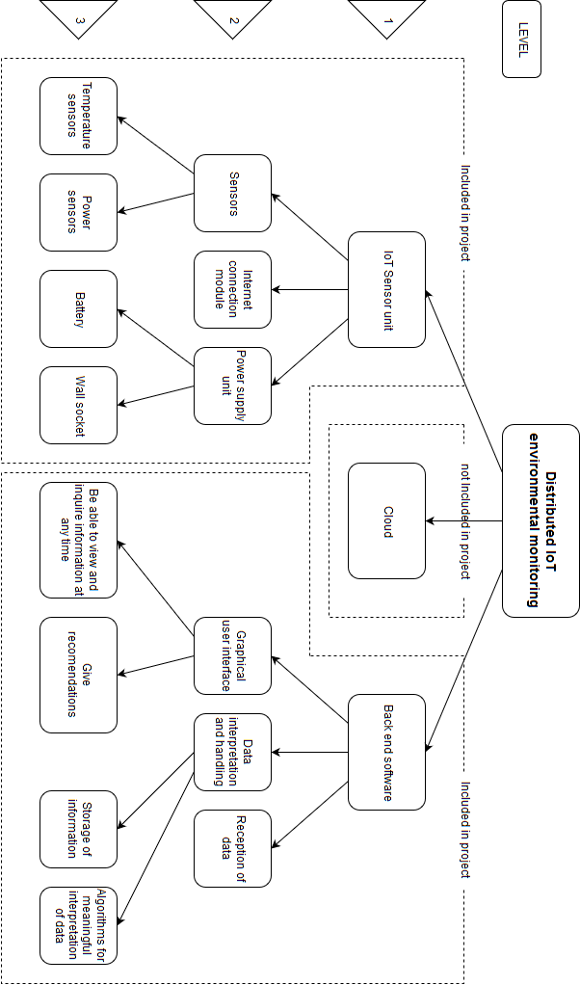

Figure 1: Work Breakdown structure

# Literature Survey

## Previous Solutions

There is no commercially available system that can be permanently installed on already operational split type air-conditioning units to monitor their COP. Currently deciding when to replace split type air-conditioning units is based on either their age or when they break.

According to the official Energy Star website [2] it is time to replace your air conditioner when it is 10 years old or when the air conditioner needs frequent repairs and your energy bill starts going up. An article on Angie’s List [3] also collaborates this stating that you should consider replacing your air conditioner if it is more than 10 years old. The article on Angie’s List [3] also gives frequent repairs as the other way to know when to replace your split type air-conditioning unit.

## Air Conditioner

The principle of an air conditioner is removing heat from one area and replacing it with cold air. The five main components of most air conditioners are as follows [4]:

* Compressor
* Condenser
* Evaporator Coil
* Blower
* Chemical refrigerant

Split type air-conditioning units consist of an outdoor unit that includes the compressor, condenser, expansion valve and a fan. Then the indoor unit comprises a cooling fan and the cooling coil or evaporator [5].

The split type air-conditioning units works by activating the outdoor compressor which starts to circulate the refrigerant gas. This circulation of the gas increases its temperature since it is compressed through a series of pipes. The refrigerant then moves to the condenser where a cooling system removes heat from the gas which then turns the gas into a chilled liquid. The chilled liquid is then transferred to the indoor evaporator. At the evaporator a fan collects warm air that is then passed through the chamber which contains the chilled liquid refrigerant. When the air leaves the chamber it is cooled and is blown back into the room by means of the fan. This process is repeated until the split type air-conditioning unit’s thermostat detects the correct temperature has been reached at which point the unit will switch off.

## COP (Coefficient of Performance)

The COP of a system is the measure of that systems amount of output power compared to the amount of input power:

|  |  |  |
| --- | --- | --- |
|  | $$COP= \frac{power output}{power input}$$ | (1) |

Equation 1: Coefficient of performance

The COP is a good indication of the efficiency of a split air-conditioner unit as it is independent of external variable, as can be seen in Equation (1) above. Other advantages of the COP are that it is instantaneous therefore it can be calculated at any point in time as power is measured is Watt [6]. Carnot’s theorem expresses the theoretical maximum COP for an air conditioning system [7]. Carnot’s theorem can be reduced to Equation (2):

|  |  |  |
| --- | --- | --- |
|  | $${COP}_{maximum}=\frac{T_{C}}{T_{H}-T_{TC}}$$ | (2) |

Equation 2: Maximum COP for an air conditioning system

In Equation (2) $T_{C}$ represents cold temperature and $T_{H}$ represents the hot temperature and both must be in Kelvin. In order to convert Celsius (°C) to Kelvin add 273.15 to the Celsius value. When using Equation (2) for space cooling the temperature inside the space will be the cold temperature and when using Equation (2) for space heating the cold temperature will be the outside temperature.

## LoRa

LoRa is a wireless technology that is power efficient and enables low data rate communication over long distances. The key features of the LoRa wireless system are the following [8]:

* Long range: 15 – 20 km
* Millions of nodes
* Long battery life: in excess of ten years

LoRa is perfect for Internet of things as it has the key requirements needed for IOT. These requirements include secure bi-directional communication, mobility and localization services [9]. LoRaWAN is a LPWAN (Low Power Wide Area Network) specification. LoRaWAN network architecture is usually a star topology that makes use of gateways as a transparent bridge to relay messages between the central network server and the end devices. The communication between the end devices and the gateways are spread between different data rates and frequency channels.

There are three main classes of end point devices which is [9]:

* Bi-directional end-devices (Class A)
* Bi-directional end-devices with scheduled receive slots (Class B)
* Bi-directional end-devices with maximal receive slots (Class C)

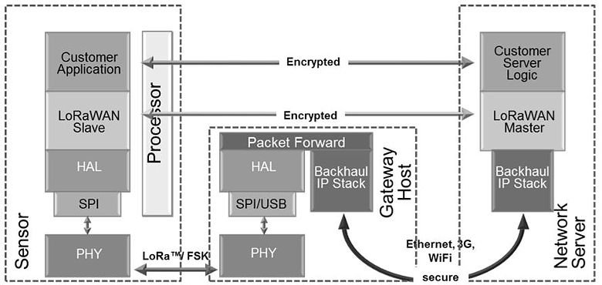

Figure 2: LoRa Network

In Figure 2 The structure of communication using LoRa is shown. The Sensor in Figure 2 communicates with the gateway that is connected to the internet so that the data can be send to the Network Server.

## Non-invasive AC Current Sensors

Is used to measure the real consumption without having to alter the electrical composition of circuit. The sensors work by acting as an inductor that responds to a magnetic field around a current carrying conductor. By making use of the following equations the sensor can determine the current in the current carrying conductor [10]:

|  |  |  |
| --- | --- | --- |
|  | $$I_{secondary}= {CT}_{turnsRatio} × I_{primary}$$ | (3) |

Equation 3: Relationship between current in the secondary and primary winding

As well as the CT turns Ratio calculation in equation (4).

|  |  |  |
| --- | --- | --- |
|  | $${CT}_{turnsRatio}= \frac{{Turns}_{primary}}{{Turns}_{secondary}}$$ | (4) |

Equation 4: CT turns Ratio calculation

In Equation (3) the relationship between the current in the secondary winding circuit ($I_{secondary}$) and the current in the primary winding circuit ($I_{primary}$) is given. Equation (4) shows the Current transformers turn ratio (${CT}_{turnsRatio}$) in terms of the relationship between the amount of turns in the primary (${Turns}_{primary}$) CT (Current Transformer) and the amount of turns in the secondary (${Turns}_{secondary}$) CT.

## Arduino

Arduino is an open source platform that is used for electronic projects due to its ease of use. Arduino consists mainly of two parts the physical programmable circuit board as well as the IDE (Integrated Development Environment) that is used to write and upload code to the board. Advantages of Arduino is as follows [11]:

* Lower cost than other similar devices
* Cross-platform
* Simple, clear programming environment
* Open source and extensible software
* Open source and extensible hardware

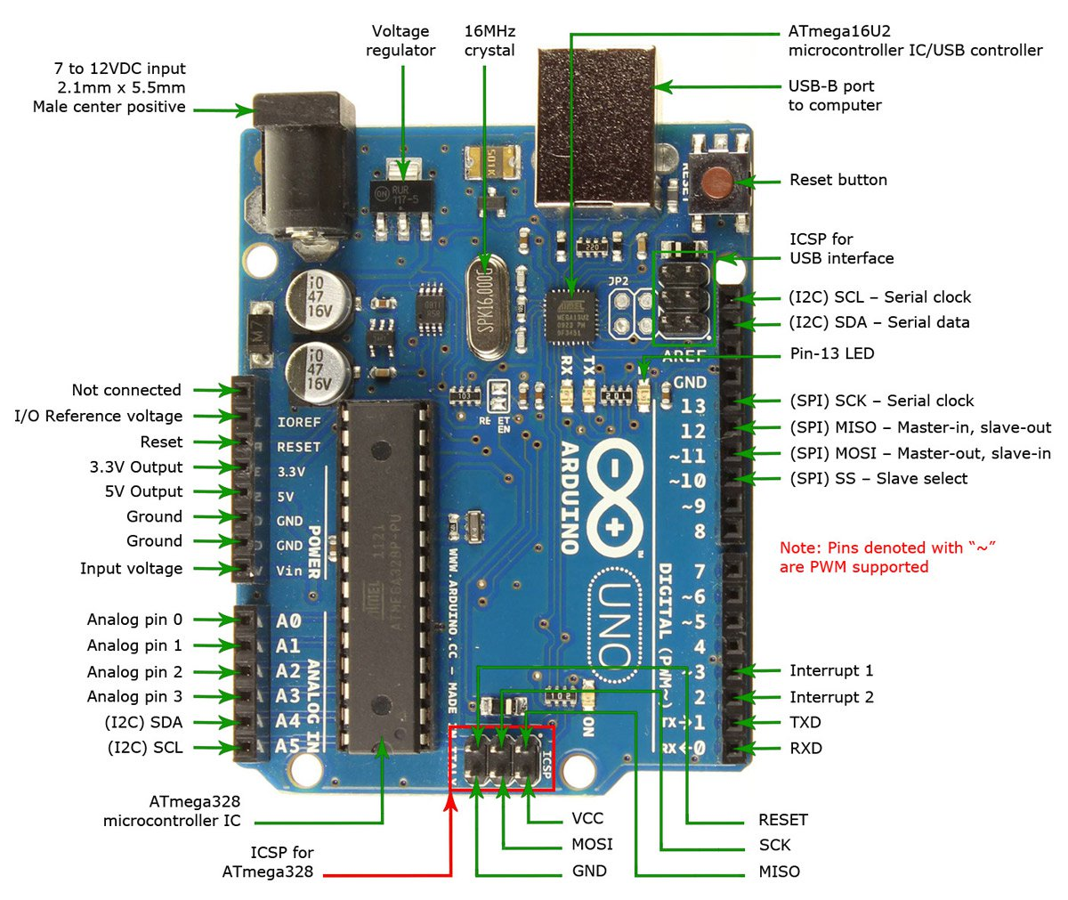

Figure 3: Arduino UNO pin layout

In Figure 3 an Arduino UNO is shown with its pin descriptions. Arduino uses a simplified version of C++ making is easy to program for anyone with knowledge in programming C. Due to the popularity of the Arduino they are easy to integrate and use with other components as there already exist libraries for a lot of components. There is an abundance of support online as well for the Arduino making it easy troubleshoot and find help if needed. There is a wide range of different Arduino boards and expansion modules making it easy to find the appropriate combination of components for your application. Arduino is readily available in South Africa at a reasonably low cost making it an ideal development board to use for a project.

## Databases

There are a two main database servers that can be considered for this project, they are MariaDB and MYSQL. Both these database servers are open source and free to use. They also both use SQL (Structured Query Language) which is an easy to use and well documented programming language with a lot of support available online. These database servers both use a broad subset of ANSI SQL 99 [12]. These reasons made these two database servers the obvious choices for the project. The server of both is ‘mysqld’ and the command-line client is ‘mysql’ with the configuration file being ‘my.cnf’. This means that both MySQL and MariaDB are compatible with each other [13]. The disadvantage of MariaDB is that MariaDB releases tend to lack behind MYSQL releases because the MariaDB developers need to merge the newly released MYSQL code into the MariaDB source trees. Advantages of the MariaDB software is that it has some added features, bug fixes, additional storage engines and performance improvements over MYSQL.

## Anemometer

Anemometers are used to measure the speed or velocity of wind and other gasses. There are a wide variety of different types which is listed below [14]:

* Vane Anemometers
* Thermal Anemometers
* Thermal Anemometers with velocity / Temperature Profiling
* Cup Anemometers

The two main classifications of anemometers are constant-temperature anemometers and constant-power anemometers. Advantages of constant-temperature anemometers are their high-frequency response, immunity from sensor burnout if airflow drops rapidly, electronic noise levels are low and they can be applied to both liquid or gas flows.

It is difficult to implement anemometers in integrated circuits because of their relative large size in comparison with other sensors such as temperature sensors. They are also quite expensive in comparison with other sensors. An anemometer that can measure CFM (Cubic Feet per Minute) can have dimensions: 181 x 70 x 35 mm (71⁄8 x 2¾ x 13⁄8") (handheld); 73 mm (27⁄8") diameter fan [15]. The anemometer costs R 3200.00. This makes such an anemometer not practical to be used in this project.

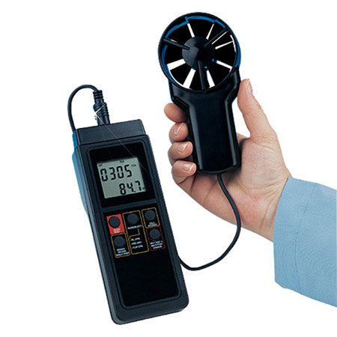

Figure 4: An HHF91 Anemometer that can measure CFM

In Figure 4 The HHF91 anemometer is shown that can measure CFM and that’s dimensions and cost is described above.

# Conclusion

In this report a definition of the project was given showing what is included in the project and what is excluded. From the research it is clear that there is no commercially available solution that offers a COP calculation to determine at which point a split type air-conditioning unit needs to be repaired or has reached the end of its life cycle. At the moment the most common solution for repairing and replacing split type air-conditioning units is by replacing them after 10 years or once they have gone through multiple repairs. The project overview section gave some detail on what methods will be used and how they will be used to complete the project.

The major obstacle the project faces is the calculation of output power from the split type air-conditioning units. There is no existing solution to easily and effectively determine the output power of the split type air-conditioning unit at any point in time.

The main focus of this report was the literature survey. The literature survey was done on the COP, LoRa, Non-invasive AC Current Sensors, Air Conditioner, Arduino, databases and the anemometer. These are all core components of the project. This project was researched in detail to ensure an in depth level of comprehension of all these aspects and components and their working.

# References

|  |  |
| --- | --- |
| [1] | Green Building Council South Africa, “GREENOVATE ENGINEERING,” Growthpoint Properties, Joahnnesburg, 2018. |
| [2] | ENERGY STAR, “When is it time to replace?,” 29 September 2017. [Online]. Available: https://www.energystar.gov/index.cfm?c=heat_cool.pr_checklist_consumers. [Accessed 10 March 2018]. |
| [3] | S. Price, “When Is It Time to Replace My Air Conditioner?,” 25 July 2015. [Online]. Available: https://www.angieslist.com/articles/when-it-time-replace-my-air-conditioner.htm. [Accessed 10 March 2018]. |
| [4] | The Air Conditioning Company, “How Does Air Conditioning Work,” 8 October 2016. [Online]. Available: https://www.airconco.com/how-does-air-conditioning-work/. [Accessed 10 March 2018]. |
| [5] | H. Khemani and L. Stonecypher, “Types of Air Conditioning Systems,” 1 January 2013. [Online]. Available: https://www.brighthubengineering.com/hvac/897-types-of-air-conditioning-systems/. [Accessed 10 March 2018]. |
| [6] | Power Knot, “COPs, EERs, and SEERs How Efficient is Your Air Conditioning System?,” Power Knot LLC, Milpitas, 2011. |
| [7] | S. Qian, Y. Geng, Y. Wang, J. Ling, Y. Hwang, R. Radermacher, I. Takeuchi and J. Cui, “A review of elastocaloric cooling:,” *international journal of r e f r i g e r a t i o n,* vol. I, no. 64, pp. 1 - 19, 2016. |
| [8] | I. Poole, “LoRa Wireless for M2M & IoT,” 15 July 2017. [Online]. Available: http://www.radio-electronics.com/info/wireless/lora/basics-tutorial.php. [Accessed 10 March 2018]. |
| [9] | LoRa Alliance, “LoRa Alliance Technology,” 17 February 2017. [Online]. Available: https://www.lora-alliance.org/technology. [Accessed 10 March 2018]. |
| [10] | G. Hudson, “CT sensors - An Introduction,” 11 January 2017. [Online]. Available: https://learn.openenergymonitor.org/electricity-monitoring/ct-sensors/introduction?redirected=true. [Accessed 10 March 2018]. |
| [11] | Arduino, “What is Arduino?,” 27 November 2017. [Online]. Available: https://www.arduino.cc/en/Guide/Introduction. [Accessed 10 March 2018]. |
| [12] | M. Sarig, “MariaDB vs MySQL: In-Depth Comparison,” 28 March 2017. [Online]. Available: https://blog.panoply.io/a-comparative-vmariadb-vs-mysql. [Accessed 11 March 2018]. |
| [13] | D. Bartholomew, “MariaDB vs. MySQL,” 9 June 2016. [Online]. Available: http://www.admin-magazine.com/Articles/MariaDB-vs.-MySQL. [Accessed 11 March 2018]. |
| [14] | OMEGA Engineering, “Anemometer: Introduction to Air Velocity Measurement,” Spectris , 6 February 2015. [Online]. Available: https://www.omega.com/prodinfo/anemometers.html. [Accessed 11 March 2018]. |
| [15] | OMEGA Engineering, “Volume-IndIcatIng thermo-anemometer KIt,” Spectris, Stamford, 2018. |